|  |  |  |  |  |  |  |
| --- | --- | --- | --- | --- | --- | --- |
|  | |  | | | | |
| **First Name** | **Thomas** | | **Family Name** | **Nguyen** | **Student ID No** | **21146348** |
| **Course Name** | **Comp 507 2023 S2** | | **Course Code** |  | **Assignment Due Date** | **24/10/23** |
| **Lecturer** |  | | **Tutorial Day** |  | **Date Submitted** | **24/10/23** |
| **Tutor** |  | | **Tutorial Time** |  | **No.Words/Pages** |  |
| In order to ensure fair and honest assessment results for all students, it is a requirement that the work that you hand in for assessment is your own work. If you are uncertain about any of these matters, then please discuss them with your lecturer.  Plagiarism and Dishonesty are methods of cheating for the purposes of General Academic Regulations (GAR) <http://www.aut.ac.nz/calendar> | | | | | | |
| **Assignments will not be accepted if this section is not completed and signed.**  Please read the following and **tick** to indicate your understanding: | | | | | | |
| 1. I understand it is my responsibility to keep a copy of my assignment. | | | | | **Yes** | **No** |
| 1. I have signed and read the **Student’s Statement below**. | | | | | **Yes** | **No** |
| 1. I understand that a software programme (Turnitin) that detects plagiarism and copying may be used on my assignment. | | | | | **Yes** | **No** |
|  | | | | | | |
| **Student’s Statement:**  This assessment is entirely my own work and has not been submitted in any other course of study. I have submitted a copy of this assessment to Turnitin, if required. In this assessment I have acknowledged, to the best of my ability:   * The source of direct quotes from the work of others. * The ideas of others (includes work from private or professional services, past assessments, other students, books, journals, cut/paste from internet sites and/or other materials). * The source of diagrams or visual images. | | | | | | |
| **Student’s Signature:** | |  | | **Date:** |  | |
| The information on this form is collected for the primary purpose of submitting your assignment for assessment. Other purposes of collection include receiving your acknowledgement of plagiarism polices and attending to administrative matters. If you choose not to complete all questions on this form, it may not be possible for the Faculty of Design and Creative Technologies to accept your assignment. | | | | | | |

**ASSIGNMENT #2 (100 marks)**

*Contribution to final marks: 50%*

*Must get a minimum of 35/100 marks in this assignment to get an overall pass for this paper*

**Submission Requirements:**

* *This is an individual assignment. The cover page must have your ID number and Name (in full)*
* Please use 1.5-line spacing and 12-point font (no handwritten assignment will be marked except for drawing the AOA diagram)
* Include page numbers.

***Task1: Project Cost Control (30 marks)***

You are required to control the budget for the MYH project. Below is the Business Case of the project.

**Table 1**

*Business Case for MYH*



* 1. What is the total budget at completion (BAC) for the project? (3 marks)
* $2,400,000.

Assume that the work for the first week is completed in the project. The following information has been provided as a result of work done so far.

Plan Value (PV) = $400, 000

Earned Value (EV) = $250, 000

Actual Cost (AC) = $600, 000

Answer the following questions (1.2 – 1.6). *You* ***must show all the workings to support your answers.***

* 1. Explain a likely reason for the difference between PV and AC for the first week of this project. (5 marks)
* Potential reasons:
* Overestimating the amount of time it takes to complete certain amount of work which can lead to more unexpected costs.
* Underestimating the loads of the work (Vague estimations).
* Miscalculations of the budget it takes to finish certain amount of work.
  1. Calculate the cost variance (CV) and the cost performance index (CPI) for the first week of this project. Is the project under or over budget? (7 marks)
* Cost Variance = EV – AC = $250, 000 - $ 600, 000 = - $350, 000.
* Cost performance index = EV/AC = $250, 000 / $ 600, 000 = 0.412.
* Project is over budget and actions to re-calculate the schedule are required.
  1. Calculate the schedule variance (SV) and the schedule performance index (SPI) for the first week of this project. Is the project ahead of or behind schedule? (7 marks)
* Schedule variance = EV – PV = $250, 000 - $ 400, 000 = - $150, 000.
* Schedule performance index = EV / PV = $250, 000 / $ 400, 000 = 0.625 = 62.5%
* The project is behind in schedule due to SPI being lower than 1 by 37.5%.
  1. Calculate the new estimate at completion (EAC) for this project after the completion of the first week’s work. (4 marks)
* Ratio of EV and AC = $250, 000 / $ 600, 000 = 0.412.
* New EAC = Total budget / new Ratio = $2, 400, 000 / 0.412 = $5, 760, 000.
  1. Calculate how long it will now take to finish this project after working on the project for a week. (4 marks)
* Earned value for the first week = $250, 000. Earned value is calculated by Total budget * % of project completion.

Therefore, we find the % of project completion by having EV divided by Total budget * 100

= $250, 000 / $ 2, 400, 000 * 100 =10.42% 🡪 10%.

Therefore, at this rate (10%/week), the project will take around 9 (9 * 10% = 90%) more weeks to complete after working on it for a week.

***Task 2: Project schedule development (35 marks)***

Table 2 shown below provides the activities (A to L) and their three-point estimates for an Auckland City IT Infrastructure (LAN Network) project.

**Table 2**

*Activities Schedule for Auckland City IT Infrastructure Project*

|  |  |  |  |  |  |
| --- | --- | --- | --- | --- | --- |
| **Task** | **Predecessor** | **Optimistic duration (Day)** | **Most Likely duration (Day)** | **Pessimistic duration (Day)** | **Task effort** |
| A | - | 12 | 14 | 26 | 16 |
| B | - | 14 | 18 | 24 | 18 |
| C | A | 21 | 23 | 32 | 25 |
| D | A | 12 | 17 | 26 | 18 |
| E | C | 11 | 13 | 16 | 14 |
| F | D | 16 | 19 | 21 | 19 |
| G | B | 8 | 6 | 11 | 8 |
| H | B | 6 | 4 | 12 | 6 |
| I | E, F, G | 8 | 6 | 13 | 8 |
| J | H | 8 | 7 | 16 | 9 |
| K | J | 9 | 7 | 13 | 9 |
| L | I, K | 10 | 8 | 12 | 9 |

* 1. Complete the PERT estimation to show the duration of each activity. (10 marks)
  2. Draw the network diagram (AOA) to show the order in which all the activities will be undertaken in this project. The diagram must be clearly labelled. (5 marks)

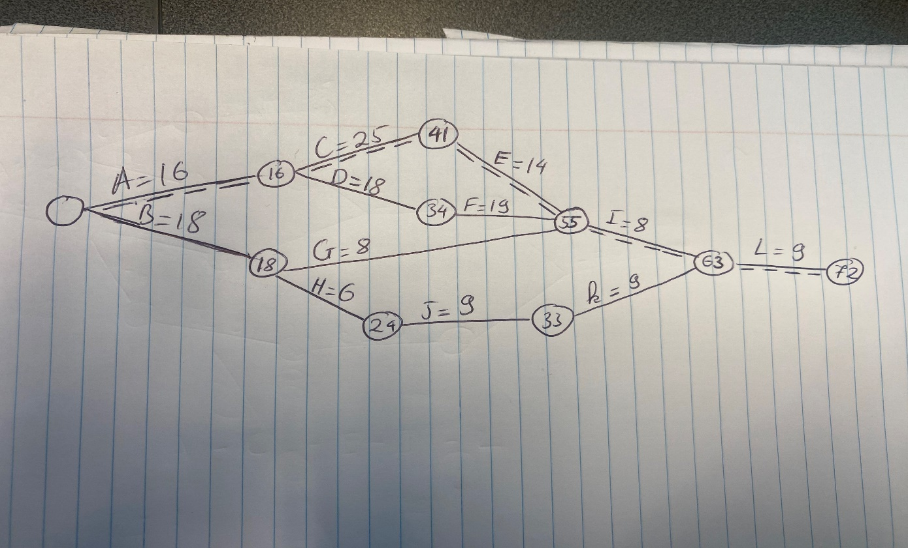

* 1. List all the possible paths for this project with their total durations. (4 marks)
* A – C – E – I – L
* A – D – F – I – L
* B – G – I – L
* B – H – J – K - L
  1. Clearly identify and briefly explain the critical path for this project. (10 marks)
* The critical path is A – C – E – I – L which takes around 72 days to finish. The Second longest path is A – D – F – I – L which takes 70 days.
  1. This network is expected to be up and running within 4 months from the time the work on the project is started. Does this opening date appear feasible? Justify with your calculations. (6 marks)
* Sounds feasible because the project is estimated to finish in 2 and a half months (72 days). The expectation (4 months) is feasible

***Task 3: Project selection (15 marks)***

You are required to perform analysis to help identify the order in which the projects will be undertaken from the available four projects.

* 1. Use the information below to create a table that must show the weighted score and priority for each project for a software vendor environment. (10 marks)

The factors that impact the success of a project include (a) the availability of a principal engineer (20%); (b) a development team assigned based on at least 4 senior software engineers with local development experience (20%); (c) availability of a product manager as an on-site customer) (20%); (d) support for the project from the sales and marketing team (20%); (e) availability of an agile tester (10%); and (f) an established product backlog based on high-level requirements (10%).

Table 3 below provides the scores based on these factors for each project.

**Table 3**

*Criteria for Projects 1-4*

|  |  |  |  |  |  |  |
| --- | --- | --- | --- | --- | --- | --- |
| **Project / Criteria** | **a** | **b** | **c** | **d** | **e** | **f** |
| Project 1 | 65 | 45 | 45 | 60 | 55 | 60 |
| Project 2 | 70 | 65 | 55 | 65 | 85 | 70 |
| Project 3 | 75 | 70 | 75 | 75 | 85 | 50 |
| Project 4 | 60 | 70 | 75 | 75 | 85 | 70 |

|  |  |  |  |  |  |  |  |  |
| --- | --- | --- | --- | --- | --- | --- | --- | --- |
| **Project / Criteria** | A (weighted) | B (weighted) | C (weighted) | D (weighted) | E (weighted) | F (weighted) | Total Score  (weighted) | Priority |
| Project 1 | 13 | 9 | 9 | 9 | 5.5 | 6 | 51.5 | 4 |
| Project 2 | 14 | 13 | 11 | 11 | 8.5 | 7 | 64.5 | 3 |
| Project 3 | 15 | 14 | 15 | 15 | 8.5 | 5 | 72.5 | 1 |
| Project 4 | 12 | 14 | 15 | 15 | 8.5 | 7 | 71.5 | 2 |

* 1. Explain the order in which these 4 projects should be undertaken. Justify with your calculations. (5 marks)

Order: 3 – 4 - 2 – 1.

* Total weighted score of project 3 is 72.5 which is the most weight therefore it has the top priority over other ones.

***Task 4: Project selection (20 marks)***

* 1. Based on the information provided below, perform a quantitative risk analysis using a decision tree diagram to calculate the **expected monetary value** (EMV) and contingency **reserve** for each project. (10 marks)

|  |  |  |  |  |  |
| --- | --- | --- | --- | --- | --- |
| Project | Risks | Chance of Outcome | Estimated Impact | Expected monetary value (EMV) | Contingency reserve |
| Project 1 | Risk 1 | 40% | -$ 60,000 | -$24, 000 | -$ 66, 000 |
| Risk 2 | 60% | -$ 70,000 | -$42, 000 |
| Project 2 | Risk 1 | 20% | -$ 100,000 | -$20, 000 | $39, 000 |
| Risk 2 | 25% | $ 60,000 | $15, 000 |
| Risk 3 | 55% | $ 80,000 | $44, 000 |
| Project 3 | Risk 1 | 20% | $ 60,000 | $12,000 | $14, 250 |
| Risk 2 | 25% | $ 75,000 | $18,750 |
| Risk 3 | 55% | -$ 30,000 | -$16, 500 |
| Project 4 | Risk 1 | 40% | $ 60,000 | $24, 000 | $18, 000 |
| Risk 2 | 35% | $ 40,000 | $14, 000 |
| Risk 3 | 25% | -$ 80,000 | -$20, 000 |

4.4 Explain the contingency reserve for each project. Justify with your calculations. (10 marks)